Data Architecture
Automated Network Request Management
Date | 26 September 2026
Team ID | ________________
Project Name | Automated Network Request Management
Maximum Marks | 4 Marks
Scope
This document covers only the creation of the database table and the creation of its fields for the Automated Network Request Management project. Flow Designer and workflow implementation are not included in this document.
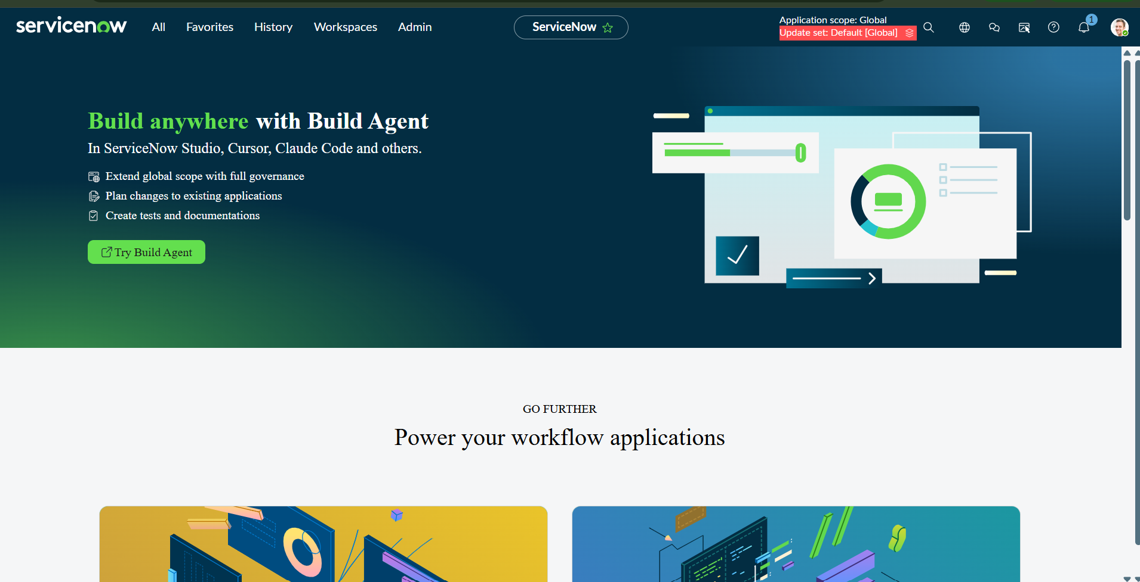
Activity 1: Creation of Table
Table Creation
Step | Action | Details
1 | Navigate to | System Definition → Tables.
2 | Create table | Click New to create a new table.
3 | Table Label | Enter: Database Tables
4 | Table Name | Enter: u_database_table
5 | Submit | Click Submit to create the table.

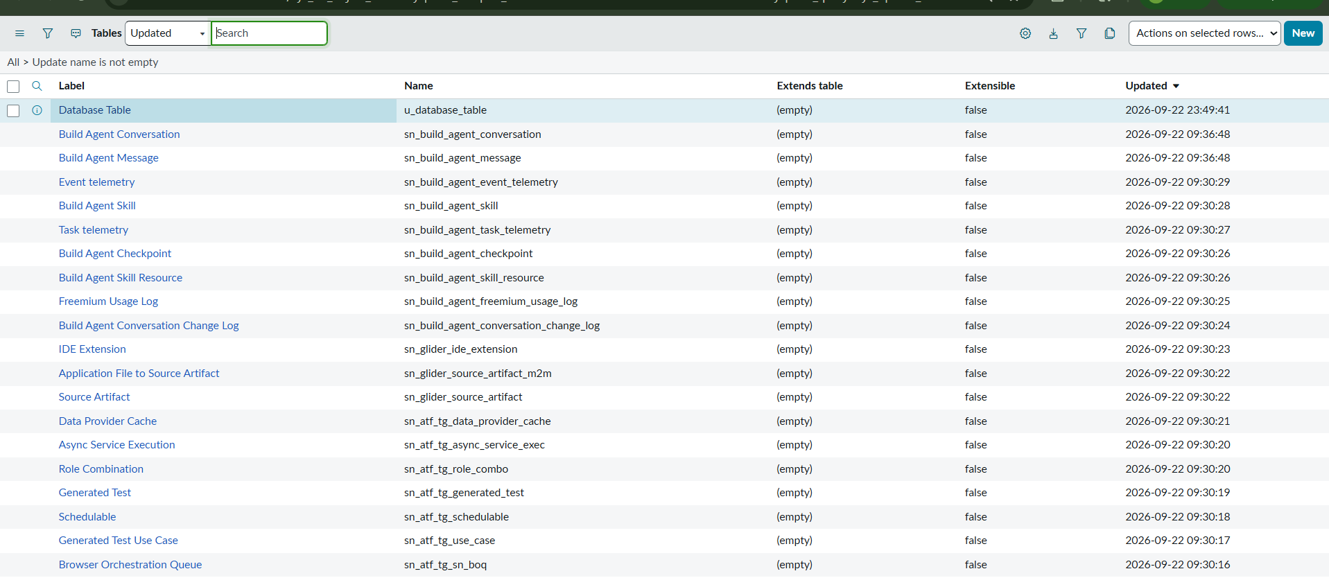
Figure 1: ServiceNow Table Creation / Table Definition
Activity 2: Creation of Fields
Create and arrange the required fields in the Database Tables table using the ServiceNow table and form configuration options.
1. Navigate to All → System Definition → Tables.
2. Search for Database Tables in the table list.
3. Open the Database Tables table.
4. Click Show Form.
5. Select Form Design.
6. Arrange the fields in the required order using Form Design.
7. In the Columns section of the Network Database table, configure the Auto Number field.
8. Provide the required Prefix and Number format for the Auto Number field.
9. Click Save to save the table and form changes.
10. Verify the newly created fields by opening a Network Database record.

Fields to Create
Field Name | Field Type | Reference
Database Number | String | —
Assignment to | Reference | user
Mobile Number | String | —
Total Amount | String | —
Mode of Payment | String | —
Type of Connection | String | —
Customer Address | String | —
Approval Status | String | —
Requested For | String | —

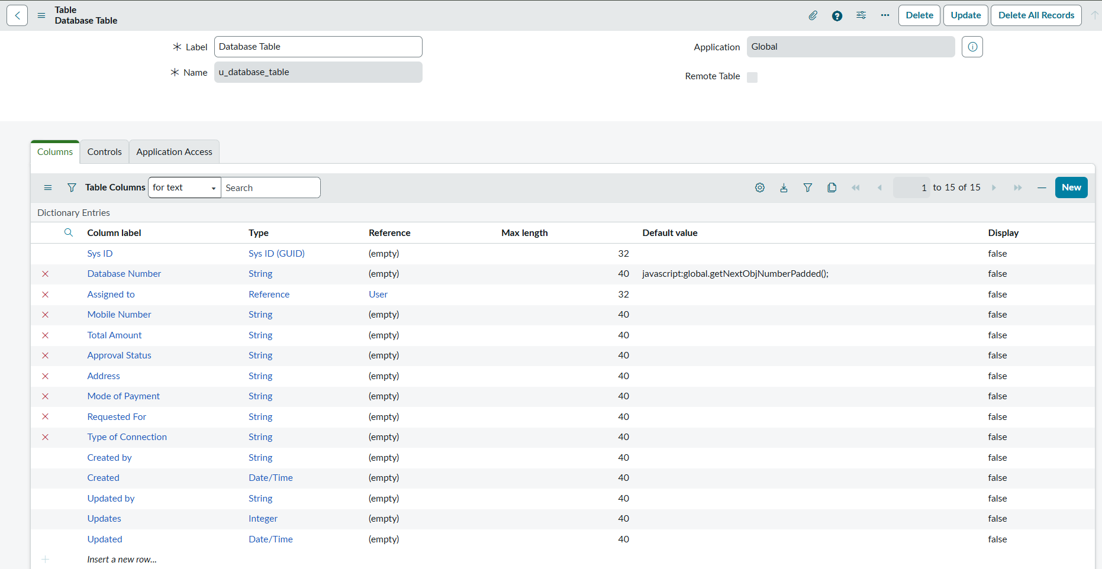
Figure 2: ServiceNow Form Design / Field Configuration
Verification
After saving the table and fields, open a Network Database record and verify that the configured fields are displayed correctly and that the Auto Number configuration produces the expected record number format.

